## Name: Hasan Fakhra

## Student Number: 19325578

# Senor Data Gathering Report

Task 1 –

I created a noise application that takes real-time gps longitude and latitude location and noise levels. These will be updated to firebase in real time from the application. This is how it looks like for now. The application works and the data will be uploaded in real-time.

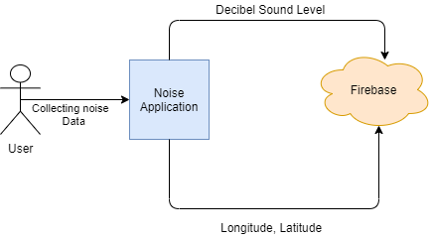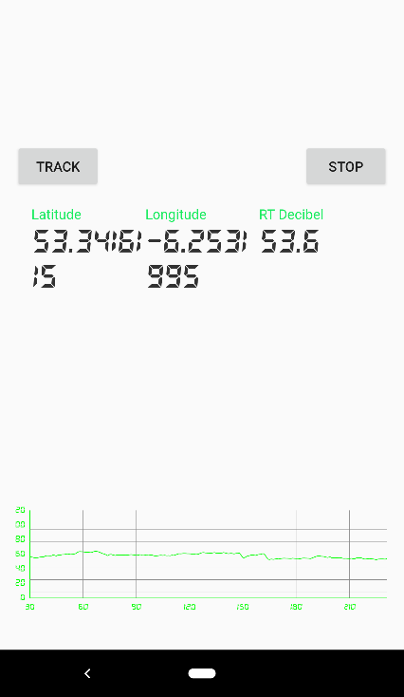

Task 2 -

Dublin City Council have an open data source for noise sensor data in Dublin. The provided API can collect different noise data from different locations in Dublin. This was provided through this link “<https://data.smartdublin.ie/dataset/noise_monitoring>”, there is also information on how to handle/code and collect the different data through the API page.

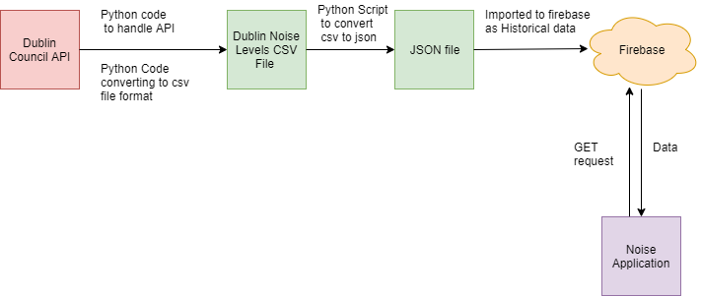

I’ve taken the python API handler and converted the csv file produced by the python code to a json file and imported it to firebase as Historical data (you can specify the date and time of the data retrieved in the python code).

The next step showcased in the diagram is the application to send GET requests to firebase to retrieve the data to be utilized in the android application.

This works perfectly for now as you can see below, this is a sample of the historical data stored in firebase

